Logo

Development Plan
Year

Include:

Executive Summary from Case for Support

Budget

SAMPLE DEVELOPMENT PLAN

Proposed Development Plan
Fiscal Year January 1, 2018-December 31, 2018
Possible Income streams
Revised

Summary |  | Stretch
Board Gifts | $25,000
Major Gifts | $100,000
Government | $150,000
United Way | $50,000
Foundation Support | $100,000
Special Event | $50,000
Annual Giving | $50,000
TOTAL | $525,000

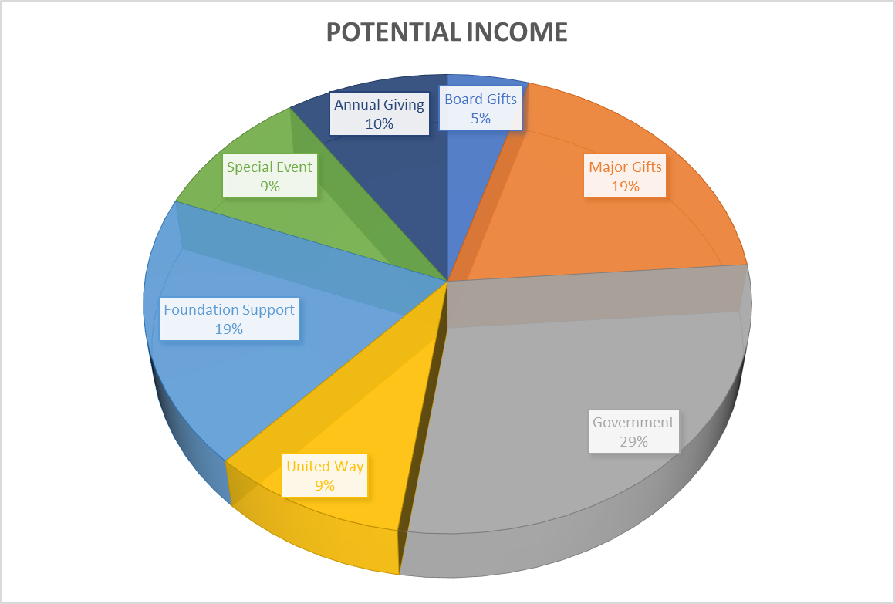
Board Gifts
Goal: $25,000 Last Year:
Responsible: Board President
Time Frame: On going
# of prospects: 30
Target: $2,500 +
Method: In-person
Direct Costs:

# | Levels | Amounts | Possible names | Visit | Ask | Result
1 | $5,000 | $5,000
6 | $2,500 | $15,000
5 | $1,000 | $5,000
 |  | $25,000

Major Gifts
Goal: $100,000 Last year: $50,000
Responsible: Board, ED and Development
Time Frame: On going
# of prospects: 30
Target: $2,500 +
Method: In-person
Direct Costs:

# | Levels | Amounts | Possible names | Visit | Ask | Result
1 | $25,000 | $25,000
4 | $10,000 | $40,000
5 | $5,000 | $25,000
10 | $2,500 | $25,000
 |  | $115,000

Suggestions:

This is where you work your list and assign potential amounts based on your research.

Government Funding
Total Goal: $150,000 Last year: $200,000
Responsible: Staff
Time Frame: In-process
Target: Federal and State Dollars
Method: Proposal
Direct Costs: Staff time (how much? Need to track)

Levels | Amounts | Possible names | Inquire | Prepare | Due | Results
TOTAL potential gifts

Suggestions:

United Way
Goal: $50,000 Last year: $50,000

Program
Responsible: Staff
Timeframe: United Way guidelines
Method:
Direct Costs: How much staff time?

# | Levels | Amounts | Visit/Inquire | Result
TOTAL potential gifts

Foundation Support:
Goal: $100,000 Last year: $

Program
Responsible: Development Staff
Timeframe: Year-round
# of Prospects: 10
Target: Local Private and Corporate foundations who have donated
In the past; other local private and corporate foundations
Method: Personal Contact
Determine grants due between January-December and possible amounts
Direct Costs: Staff time: Research, prepare, submit, report

# | Levels | Amounts | Possible names | Inquire/Visit | Prepare | Due | Results
1 | $50,000 | $50,000
2 | $25,000 | $50,000
3 | $10,000 | $30,000
TOTAL potential gifts |  | $130,000

Suggestions:
Previous Foundation Support
Research new Foundation Support
Special Events:
Total Goal: $50,000 Last year: $30,000

Special Event: SPONSORSHIPS
Responsible: Board and Staff-plan and implement
Time Frame: Ongoing
# of prospects: n/a
Target: Community interest
Direct Costs: Staff time
Volunteer time
Board time

# | Levels | Amounts | Possible names | Inquire/visit | Ask | Result
TOTAL potential gifts

Suggestions:
From the fund development committee, create a committee for special event
Coordinate which sponsors will be asked for each event
Create Budget for the event. Need to determine expenses to make sure you net this amount for each event
Create Timeline for event.

Annual Giving
Direct Mail
Goal: $50,000 Last year: $50,000
Responsible: Staff plans, creates, prints and mail out
Board shares names and addresses/signs letters
Time Frame: 2 x times a year February/November
# of prospects: Target: $250 < (includes memorials and in honor of…)
Method: Direct Mail
Direct Costs: Postage, stationary and return envelopes
# | Levels
10 | $1,000 | $10,000
10 | $500 | $5,000
75 | $100 | $7,500
50 | $50 | $2,500
100 | <$50 | $5,000
 |  | $30,000.00

Spring Appeal - Newsletter

Fall mail appeal
# | Levels
10 | $1,000 | $10,000
10 | $500 | $5,000
75 | $100 | $7,500
50 | $50 | $2,500
100 | <$50 | $5,000
 |  | $30,000.00

Suggestions:
Need to create names for various giving levels and types of recognition received

Stewardship activities must be included in the Development Plan, however there are no monetary goals established.

Planned Giving should also be incorporated into the FR calendar.
Proposed Fundraising Schedule
January
Policies and Procedures
- Review Development Audit and begin working on recommendations
- Review Gift Acceptance Policies, present to board for approval
- Begin to develop policies and procedures manual for the development office

Budget
- Finalize development budget to include income and expenses
- Review and finalize development plan

Foundations
- Review private, corporate and government Foundation lists and determine who to submit proposal to and for what amounts and for what projects (program or facility)
- Determine deadline dates and update calendar
- Update attachments for proposals – budgets, cover letter, case for support

Board Solicitation

Special Event
- Secure location and date
- Create and send invitations

Major Gifts

Stewardship

February
Development Plan
- Review

Foundations
- Prepare and submit grant proposal

Board Solicitation

Spring Appeal
- Write letter
- Create mailing list
- Review and update mailing list for those prospects giving $1,000 or less
- Assign names to giving levels
- Update giving cards to reflect giving levels and amounts
- Create letter for end of year appeal
- Create thank you letter for spring mail appeal

Major Gifts

Stewardship

March
Development Plan
- Review plan – are we on track with Development budget?

Major Gift Appeal
- Determine prospects giving $2,500+ for major gifts appeal
- Assign prospect names to giving levels
- Assign board volunteers to call upon prospects
- Finalize giving brochure to share as part of these calls.
- Determine when solicitation will begin
    - Create thank you letter for major gift appeal
    - Schedule follow-up meetings with teams to determine status
    - Continue acknowledgments of support as received

Spring Appeal
- Print
- Send to those giving $1,000 or less
- Prepare letters and have board members sign with personal notes

Foundation proposals
- Review lists

Major Gifts

Stewardship

April
Development Plan
- Review

Direct Mail
- Continue acknowledgment of support

Major Gifts

Stewardship

May
Development Plan
- Review

Major Gift Appeal Committee
    - Complete solicitation
    - Schedule final meeting to share results

Special Event: Fall Event
- Review Budget and create task list
- Determine date – check UW and Chamber of Commerce Calendars for conflicts
- Review underwriting sponsorships levels
- Determine underwriting sponsors needed
- Create underwriting sponsorship letter
- Secure location for Banquet
- Determine need for audio/video and power point presentation
- Determine need for photographer
- Determine caterer, tables, chairs etc.

Stewardship

June
Development Plan
- Review plan – are we on track with Development budget?

Major Gifts

Stewardship

July
Development Plan
- Review

Major Gifts

Stewardship

August
Development Plan
- Review

Major Gifts

Stewardship

September
Development Plan
- Review plan – are we on track with Development budget?

Foundations
- Determine need for end of year funding
  - Review foundation dates due and determines next round of grants.
- Prepare a timeline for proposal submission.

Major Gifts

Stewardship

October
Development Plan
- Create development budget for 2018 based on organizations needs and results from 2017 fundraising efforts.
- Finalize organizational budget to include income and expenses

Direct Mail Appeal
- Review and update mailing list for those prospects giving $1,000 or less
- Assign names to giving levels
- Update giving cards to reflect giving levels and amounts
- Create letter for end of year appeal
- Create thank you letter for fall mail appeal
Major Gifts

Stewardship

November
Development Plan
- Review

Direct Mail Appeal
- Direct Mail Appeal
- Prepare letters and have board members sign with personal notes
- Continue to send acknowledgments for support.

Major Gifts

Stewardship

December
Wrap up
Create 2019 Development Plan based on 2018 results and annual budget.

Major Gifts

Stewardship
- Send holiday card (not a request for money)

*Sample provided by Patti Ward, CFRE – adapted from Association of Fundraising Professional sample.*

